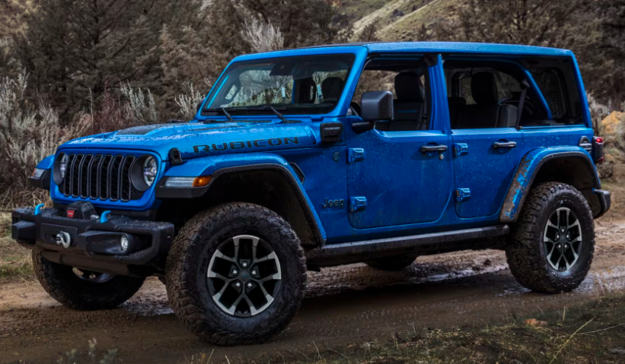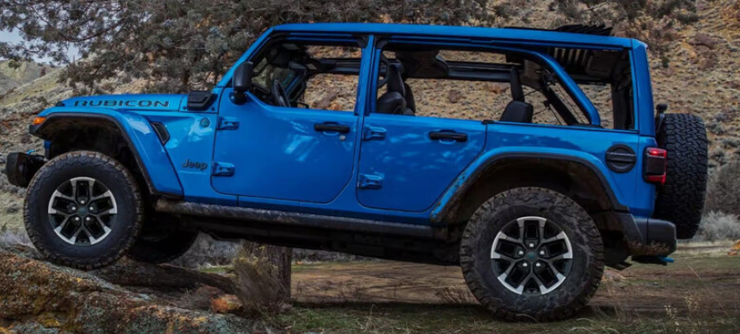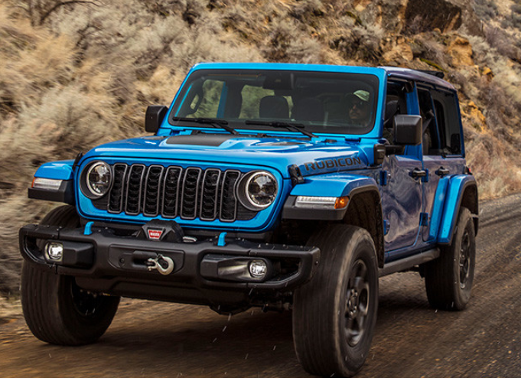

**Main Specifications** for the **2025 Jeep Wrangler**

**🚙 Powertrain & Performance**

**Engine Options:**

* **3.6 L Pentastar V6** (ICE): 285 hp @ 6,400 rpm, 260 lb‑ft torque; manual 6‑speed; towing ~3,500 lb
* **2.0 L Turbo I4** (ICE): 270 hp, 295 lb‑ft; paired with 8‑speed automatic; towing ~5,000 lb
* **4xe Plug‑in Hybrid**: Turbo 2.0 L + 2 electric motors; total 375 hp and 470 lb‑ft; ~21 mi all-electric range; e‑range ~35 km, ~49 MPGe
* **6.4 L HEMI V8 (Rubicon 392 Final Edition)**: 470 hp and 470 lb‑ft; 0‑60 mph in ~4‑5 s; 3,500‑lb towing
* **Transmissions & Drivetrain:**
* 6‑speed manual (V6), 8‑speed auto (others); 4WD standard across all trims

**📏 Dimensions & Capacity**

**Body & Weight:**

* **4-door (Unlimited)** length: 188.4″ (4,785 mm); width: ~74″; height: ~75″
* **Ground Clearance** (Rubicon style): ~9.7–12.9″ (246–328 mm)
* **Curb Weight**: ~4,010 lb (V6) to ~5,075 lb (4xe hybrid)
* **Interior & Cargo:**
* Seating: 4 or 5 (two front, bench rear)
* Cargo behind rear: 365 L (13 cu ft); up to 898 L for 2‑door, 1,909–2,050 L for 4‑door when seats down

**🛠️ Off‑Road & Chassis**

* Body-on-frame, solid front/rear axles, 5‑link suspension
* **Trail-rated features** (Rubicon/4xe/Willys): Dana 44 axles, 33″ tires, sway-bar disconnect, Tru‑Lok electronic lockers, rock rails, skid plates
* **Approach/Departure angles**: ~41°/36°; **Breakover**: ~25–27°

**🛡️ Safety & Technology**

* **Uconnect 5** with 12.3″ touchscreen, wireless CarPlay/Android Auto, 8‑speaker Alpine system
* **Driver aids**: Blind‑spot, rear‑cross traffic, forward‑collision warning, adaptive cruise, lane‑departure, trailer sway control, hill‑descent, ParkView/ ParkSense camera/sensors
* **Structural safety**: Roll-over protection, multistage front/side airbags, anti‑roll‑bar, ESC, traction control

**⛽ Fuel & Efficiency Overview**

* **3.6 L V6**: ~19 mpg combined; **2.0 L Turbo**: ~23‑26 mpg highway; **4xe hybrid**: ~49 MPGe combined (~21 mi electric); **V8**: ~12 mpg combined

**✅ Summary**

The **2025 Jeep Wrangler** offers unmatched versatility:

* Choose from a fuel-saving V6 manual, efficient turbo four, plug-in hybrid 4xe, or high-performance V8
* Class-leading **4WD and off-road features**, especially in Rubicon/Willys/4xe trims
* Strong capability: up to 5,000 lb towing and nearly 2,050 L cargo
* Modern tech with touchscreen, connected services, and robust safety suite